**HTML Assignment WEEK - 1**

Recreate the web page which is shown below.

**HOME PAGE:**

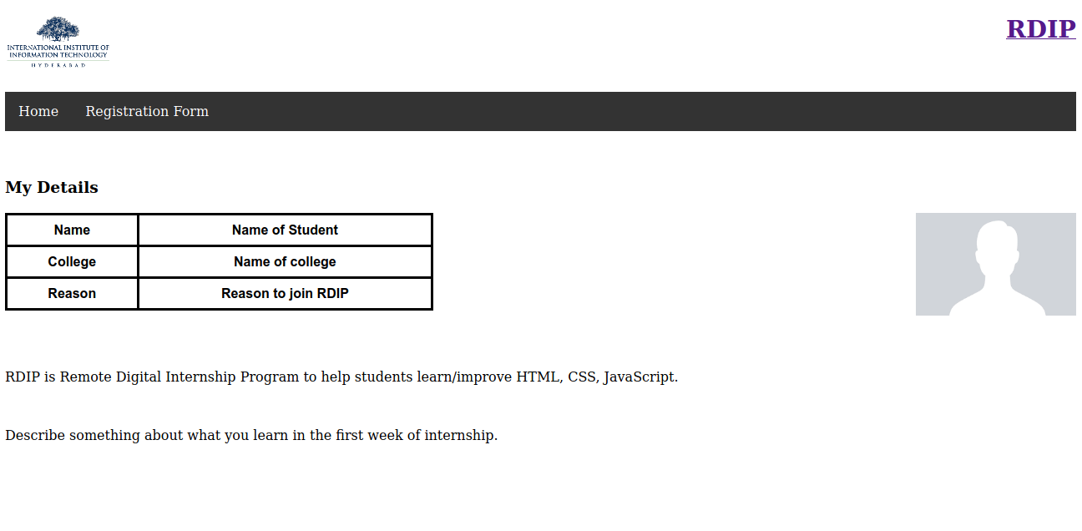

**REGISTRATION PAGE:**

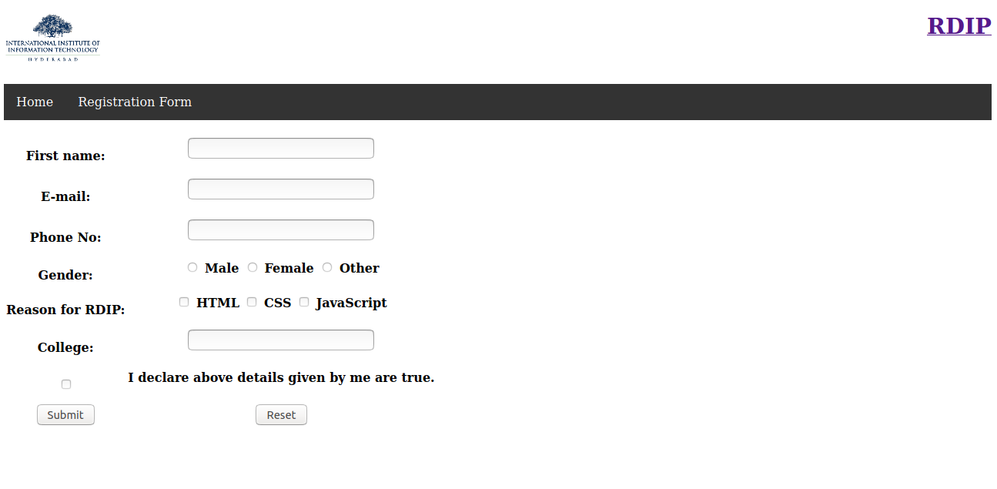

**DETAILS PAGE:**

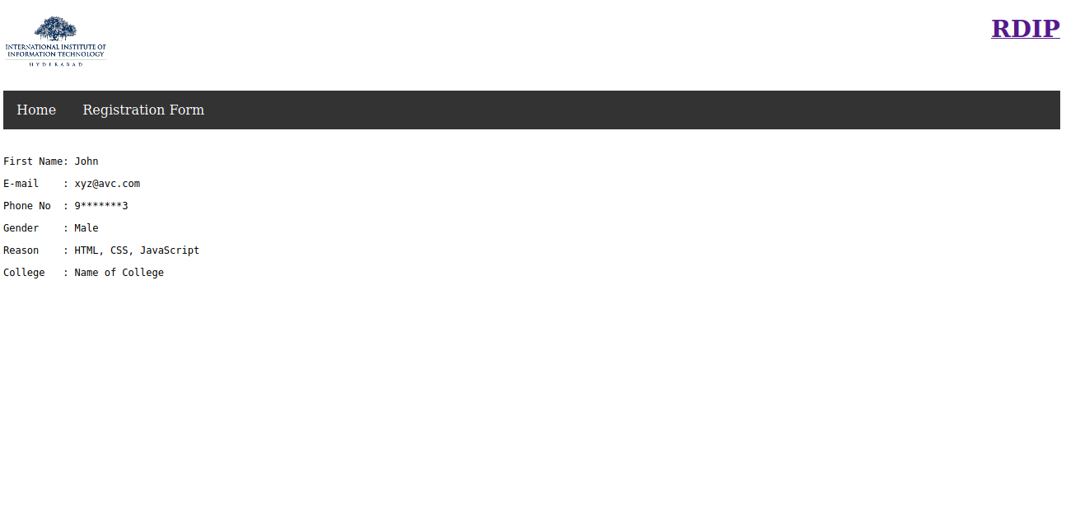

Common to All Pages:

1. Top left logo is the logo of IIIT-H (<https://www.iiit.ac.in/img/iiit-new.png>). That image should redirect to the IIIT-H web page ( <https://www.iiit.ac.in/> ).
2. Top right is the RDIP text, and text needs to be redirected to the RDIP web page ( <https://serc.iiit.ac.in/rdip> ).
3. You have to submit all 3 filenames below in the “rdip” repository only. Please make sure you submit it in this particular repository name only.
4. When clicked on “Home” it should redirect it to the “**homepage.html**”.
5. When clicked on the Registration form it should redirect to the Registration form page **“registration.html”**.

**NOTE**: File names should be the one with highlighted, else the files would not be considered for evaluation.

Home Page:

1. The profile image should be aligned to the right of the screen as shown in the above image.

Registration Page:

1. A form can be submitted only after filling all the fields as mentioned in the image.
   1. The form method should be “GET”.
   2. On submitting the form, the page should redirect to the Details page “**details.html**”.
   3. All fields are mandatory.

Details Page:

1. The html file for the details page should be “details.html”
2. All the details should be hardcoded i.e whatever information you think the user will enter in registration.html should be in details.html. You can also hardcode exactly what we have given in the image, so name as John, gender as Male and so on.